**ASSIGNMENT 3**

**CLOUD APPLICATION DEVELOPMENT**

|  |  |
| --- | --- |
| Team Id | **PNT2022TMID32730** |
| Student name | D HARI PRASATH |
| Maximum marks | **2** marks |

**Question-1:**

Create a Bucket in IBM object storage

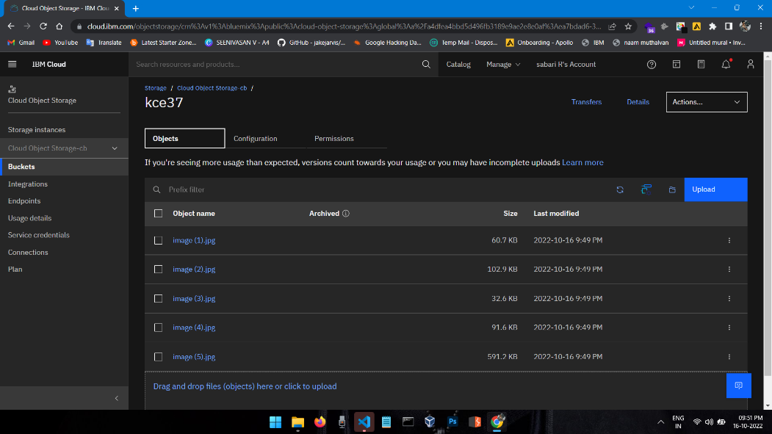

**Question-2:**

Upload 5 images to IBM object storage and make it public. Write html code to display all 5 images

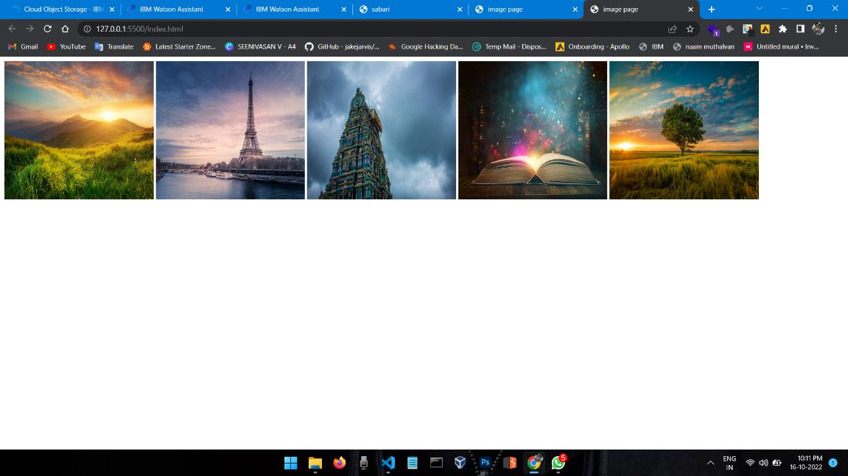

**Question-3:**

Upload a CSS page into the object storage and use the same page in your html code.

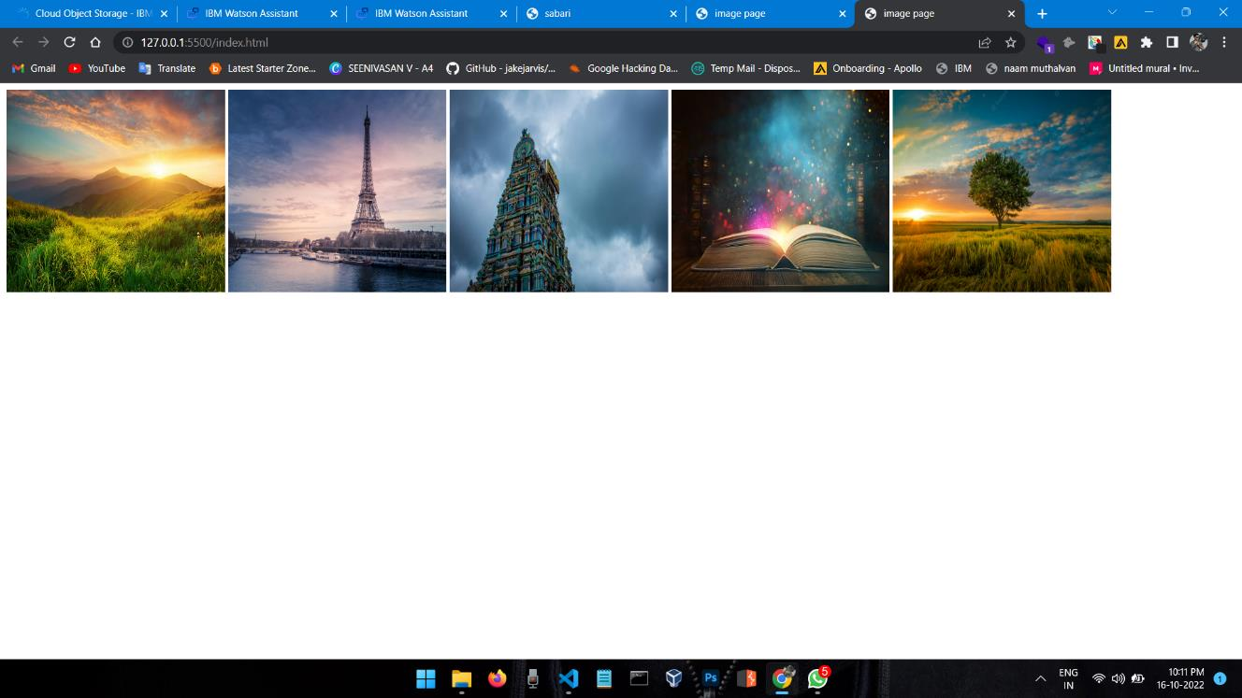

**Question-4:**

Design a chatbot using IBM Watson Assistant for hospital. Ex. User comes with query to know the branches for the hospitals in your locality. Submit the web URL of that chatbot.

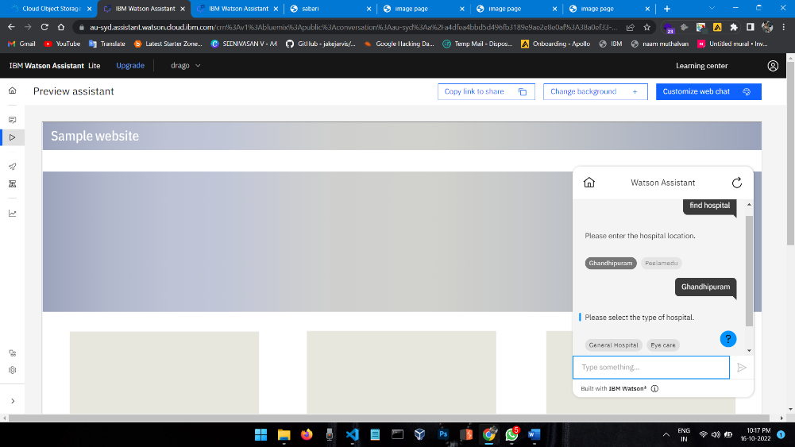Web URL Link **: Click Here to open WEB CHATBOX**

**Question-5:**

Create Watson assistant service with 10 steps and use 3 conditions in it. Load that script in HTML page.

